

**Mawlana Bhashani Science and Technology University**

**Lab-Report**

Report No: 05

Course code: ICT-4202

Course title: Wireless and Mobile Communication Lab

Date of Performance: 18.09.20

Date of Submission: 25.09.2020

**Submitted by Submitted To**

Nazrul Islam

Assistant Professor

Dept. of ICT

MBSTU.

Name: Tushar Das

ID: IT-16016

4th year 2ndsemester

Session: 2015-2016

Dept. of ICT

MBSTU.

**Experiment No: 05**

**Experiment Name:** **Comparative Analysis of Wired and Wireless data using Wireshark**

**Objectives:**

1. To find out the wired data packages using the Wireshark in order to compare with the wireless data packages.
2. Filtering the packages
3. Finding out the host, IP of the data packages
4. Showing the Statistics for both of the data packages.
5. Finally comparing the wired and wireless data packages simultaneously with the help of Wireshark.

**Capturing Packets:**

After clicking the “option” under the menu tab, we need to start capturing on interface that has IP address/Source/Host.

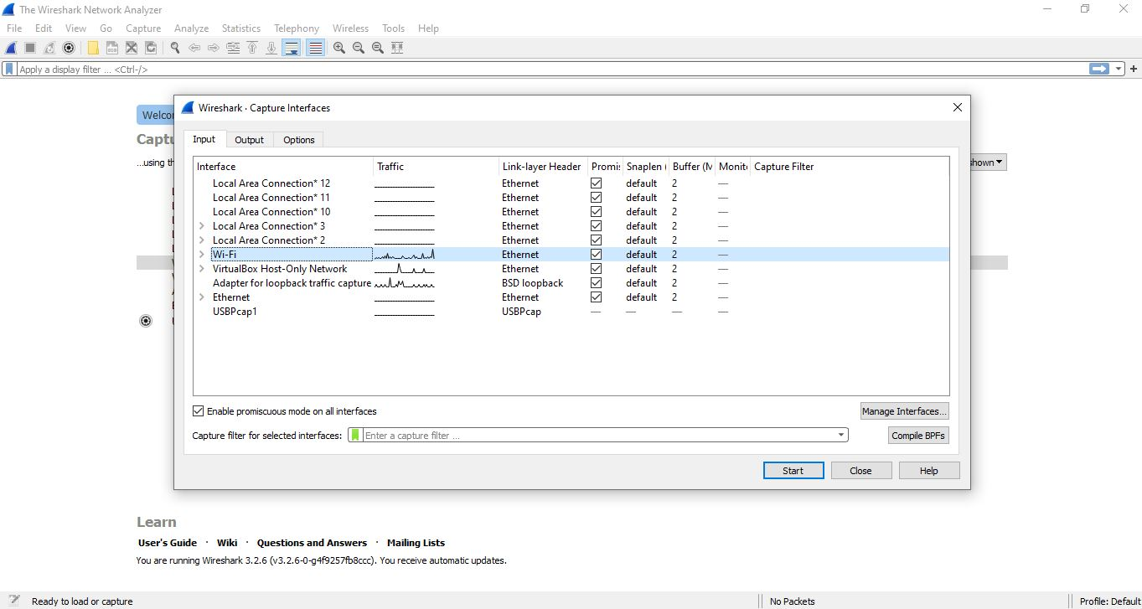

**Fig: Capturing Interface that has for Wi-Fi (Wireless)**

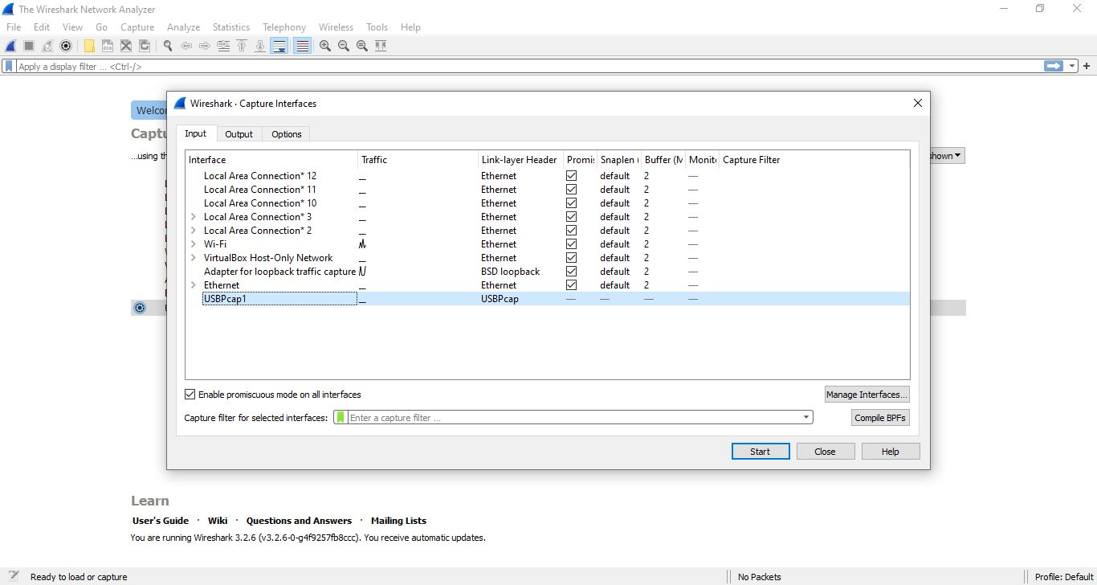

**Fig: Capturing Interface that has for USB Tethering (Wired)**

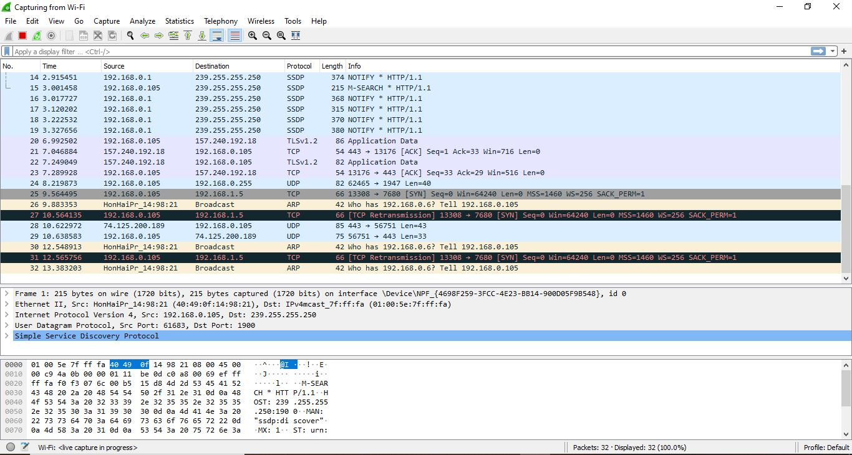

**Fig: A sample packet capture window for Wireless Data Pack**

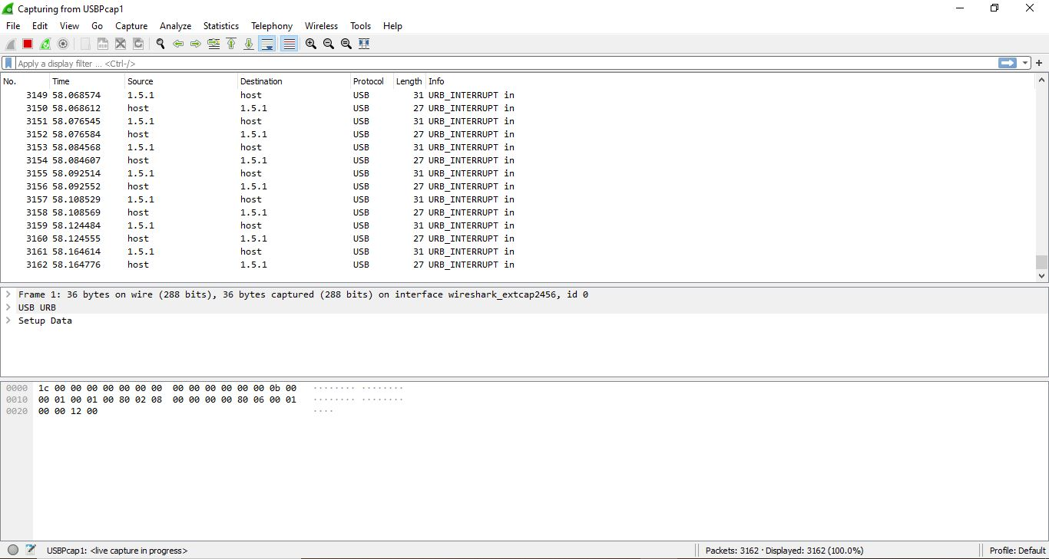

**Fig: A sample packet capture window for Wired Data Pack**

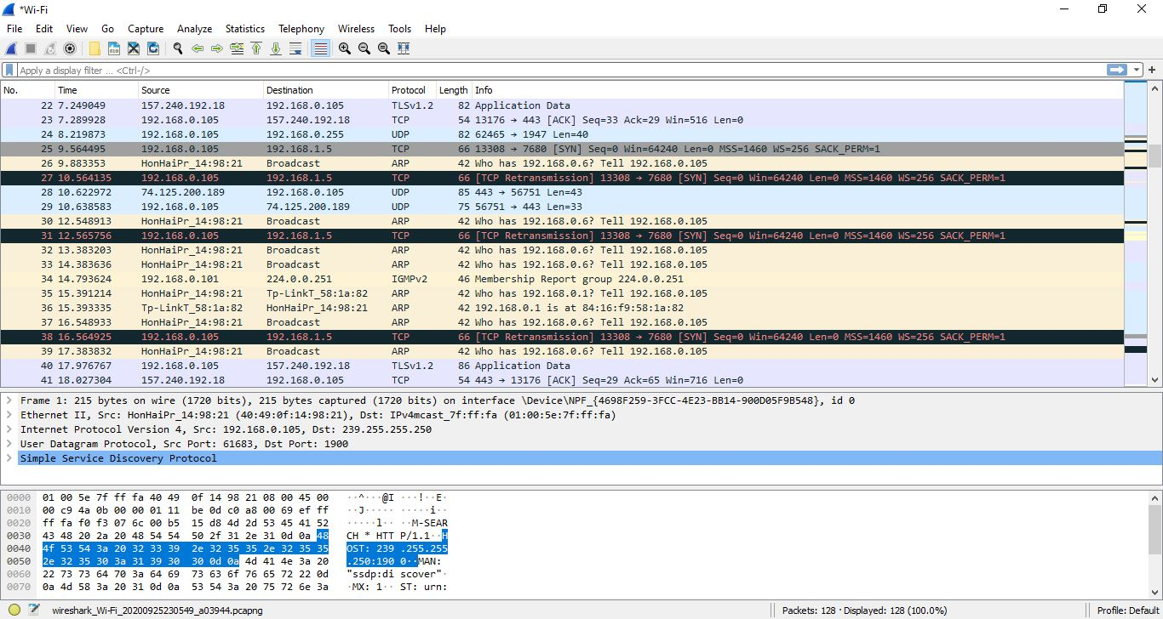

**Fig: Stopped wireless capturing**

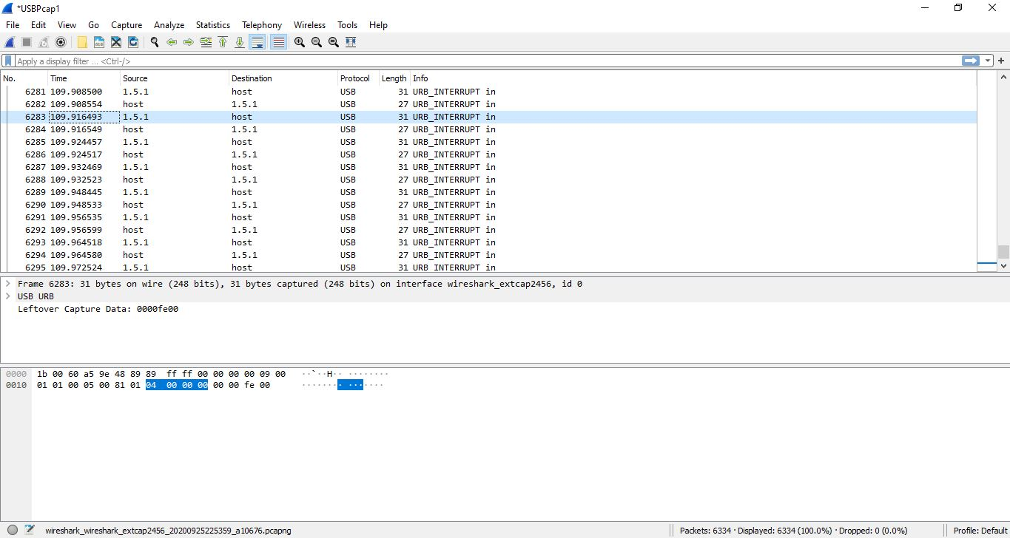

**Fig: Stopped wired capturing**

**Filtering:**

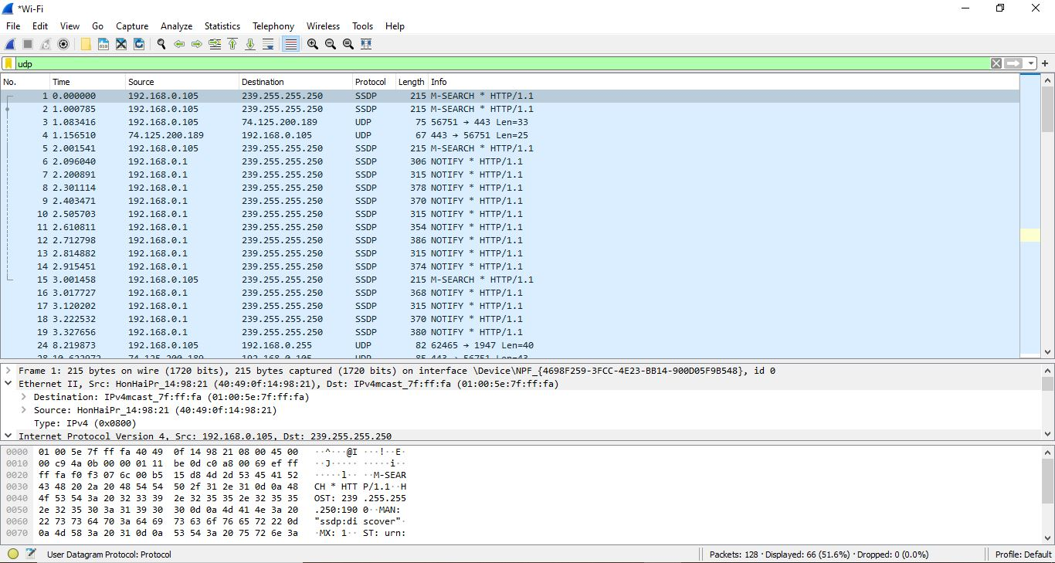

**Fig: Filtered by Protocol Wireless Data Packages**

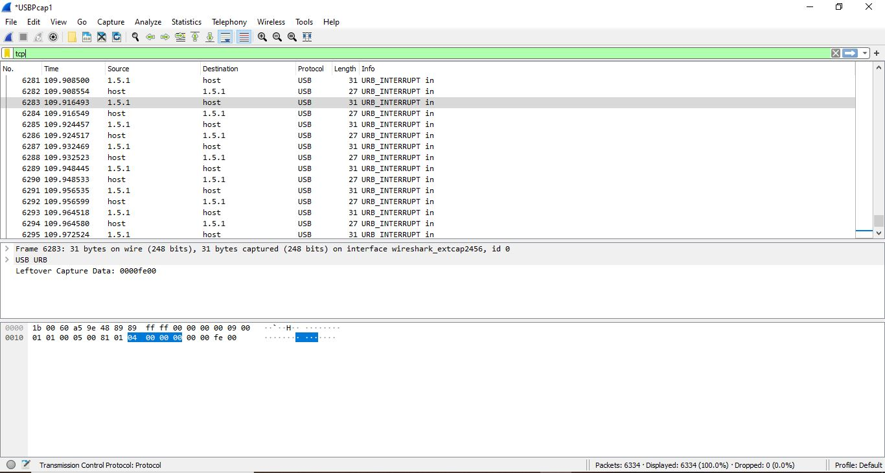

**Fig: Filtered by Protocol Wired Data Packages**

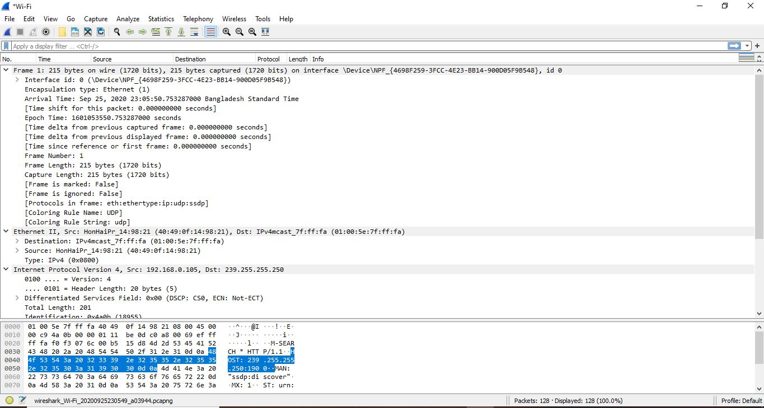

**Fig: Packet Details Pane (Frame segment) for Wireless Data Packages.**

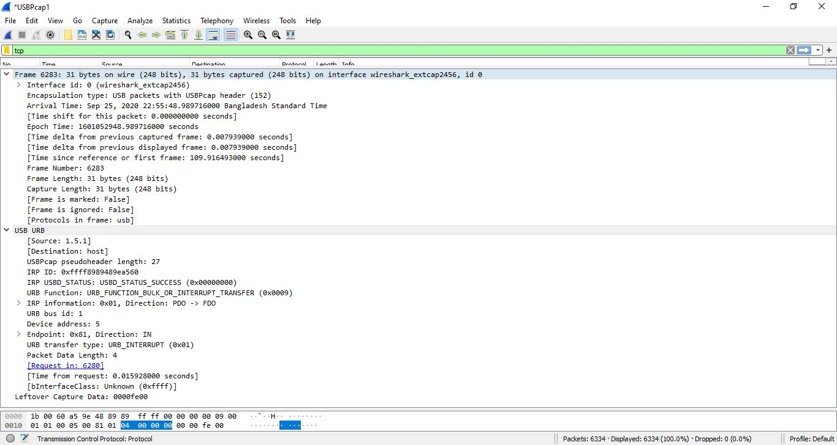

**Fig: Packet Details Pane (Frame segment) for Wired Data Packages.**

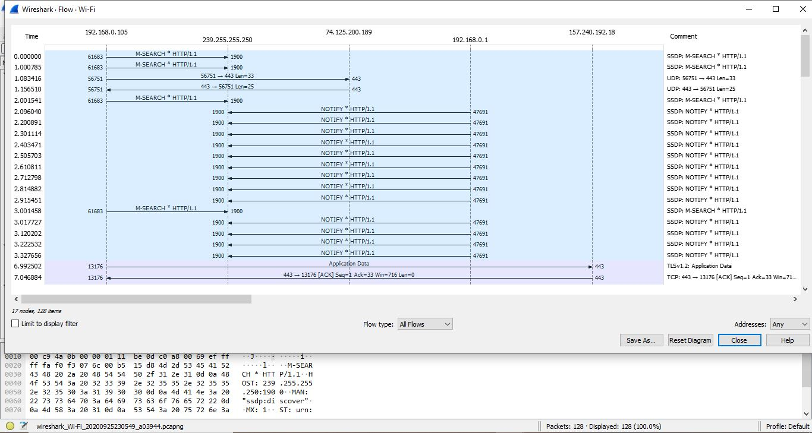

**Fig: Statistics- Flow Graph -All Flows for Wi-Fi (Wireless Data Packages)**

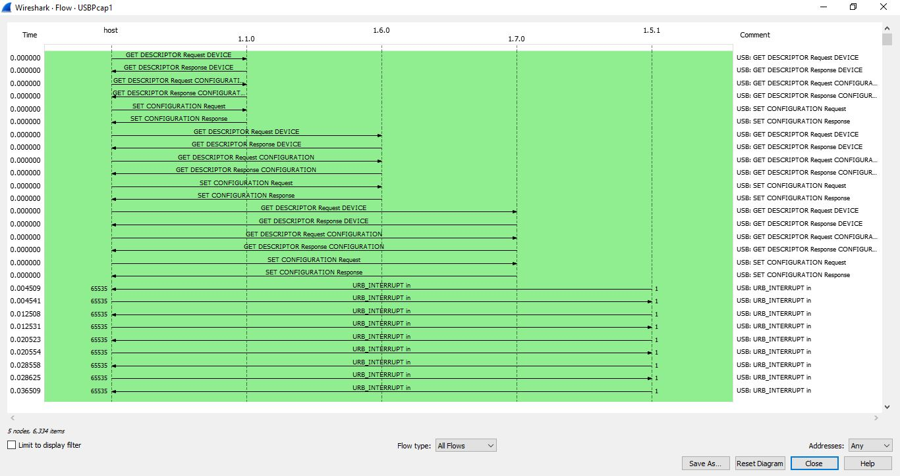

**Fig: Statistics- Flow Graph -All Flows for Wi-Fi (Wired Data Packages)**

**Conclusion:**

Between Wired and Wireless Network, wired network is much more efficient than wireless network. Because wired data packages transfer rate are very much smoother than Wireless.

Wired data are more secure and high speedy, On the other hand wireless data are less secure and low speedy.